**Leader Overview**

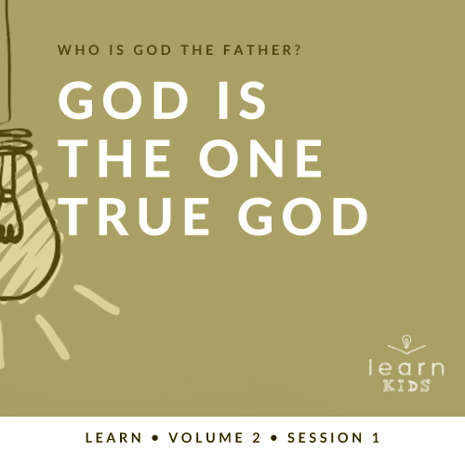

**Who is God the Father?**

*God the Father chose to reveal who He is throughout His Word. A robust picture of God can be seen by looking at His interactions with men and women like us. Since people first sinned in* [*Genesis 3*](https://ref.ly/logosref/Bible.Ge3)*, every generation has had to connect with our invisible God for themselves. Through these sessions about God, you have the opportunity to pass on this life-changing relationship to kids*.

**God Is the One True God**

*This session’s Bible story is just one example of how God has proven to people that He is the one true God. As Christians, we believe in and serve God who reveals himself in three Persons—God the Father, Jesus, and the Holy Spirit. The world will provide many false alternatives, but we must place our trust only in the one true God*.

**Bible Lesson**

God Delivers from the Fire

[Daniel 3:1–30](https://ref.ly/logosref/Bible.Da3.1-30)

**Faith Fact**

My God is the one true God.

**Faith Verse**

[Isaiah 55:8](https://ref.ly/logosref/Bible.Is55.8) (NLT)

“My thoughts are nothing like your thoughts,” says the Lord. “And my ways are far beyond anything you could imagine.”

**Preparing for the Session**

**Leader Preparation Time: 20–25 Minutes**

|  |
| --- |
| ***You Will Need***  ***Large Group***   * *Bible* * *Worship songs (Song suggestions: “Your Love Awakens Me” by Phil Wickham; “Goodness of God” by Bethel Music; “Move” by Jesus Culture; “Faithful Now” by Vertical Worship)* * *For groups not using a phone or tablet only, add:*   *• Projector or TV*  *• Laptop*  *•* ***Faith Fact Slide***  *•* ***Faith Verse Video*** *or* ***Slide***  *•* ***Bible Lesson Video***  *•* ***Teaching Point Slides 1–3***  *• Cell phone*  *• Video game or game app*  *• Money*  ***Small******Group***   * *Bibles for kids in your group to share* * ***Small Group Faith Verse Review****, one set per kid, pair, or team* * *Scissors* * ***Small Group Activity Page****, one per kid* * *Pencils or pens, one per kid*   *To access session content from a computer, visit:*  [*BibleEngagementProject.com/downloads*](https://bibleengagementproject.com/Downloads) |
| ***Getting Ready***  ***Large Group***   * *Download videos and slides if needed.* * *Select worship song(s) and have them ready to play.* * *Read the Bible Lesson Scripture to prepare for teaching time.*   ***Small Group***   * *Print and cut out the pieces of the* ***Small Group Faith Verse Review****, one set per kid, pair, or team.* * *Print copies of the* ***Small Group Activity Page****, one per kid.*   *First time leading* Learn *for Kids? Check out the* [*Facilitator Guide*](https://0b769b0ed3569ef9d18b-f88d8272f61086866d50d048b43ef630.ssl.cf2.rackcdn.com/sites/biblengagementproject/Listen_Facilitator_Guide.pdf)*.* |

**Large Group**

**30 Minutes**

*See what’s needed at the beginning of the session.*

**Introduction**

Hey, everyone! I’m so glad you joined me. For our next few times together, we’ll answer a very important question for our Christian faith: Who is God the Father? Knowing who God is helps us understand how He works. It also helps us get to know Him better. What are some words that come to mind when you think about God the Father? *(Allow responses.)* Those are some great answers.

**Faith Fact**

Today’s Faith Fact gives us one of the many answers to who God is. **My God is the one true God**.

• *Show the* ***Faith Fact Slide***.



Can you say that with me? **My God is the one true God**. I think we can do better than that. Stand up. Point up with your index finger. Then, shout our Faith Fact. **My God is the one true God**. *(Group response)* Great job! Go ahead and be seated.

**Game**

**Last One Standing**

The God we believe in and serve is the one true God. Some people believe there are other gods, many gods, or no god at all. I want to make sure you know the truth. Our God will be around forever, but everything else people call a god will eventually be gone. We’re going to play a game called “Last One Standing.”

Here’s how to play. I’ll read some things that describe people. If it’s true about you, you’ll sit down. We’ll see who’s standing at the end of the game.

• *Have everyone stand up*.

• *Read the following statements. Then pause after each one for kids to sit down in response*.

• *You may need to make up some of your own statements*.

• *Keep playing until you get down to one kid left standing*.

• Sit down if you’re wearing the color red.

• Sit down if you ate cereal for breakfast today.

• Sit down if you have at least one brother and one sister.

• Sit down if you have a pet cat.

• Sit down if you’re wearing tennis shoes.

• Sit down if you love peanut butter.

• Sit down if you have blue eyes.

• Sit down if you have short hair.

• Sit down if you like to read.

• Sit down if you play on a sports team.

That was a lot of fun, and I learned a lot about all of you.

**Worship**

Standing up for God is a focus of our Bible story today. Let’s stand up and worship Him by singing now.

• *Lead the kids in singing one or two praise songs. See suggestions at the beginning of the session*.

**Bible Lesson**

I hope you enjoyed our time in worship. Let’s get ready to find out what God has to teach us today. We’ll learn who God the Father is and how that knowledge affects how we should live as His follower. Let’s pray and ask God to help us listen to His Word today.

**Prayer**

|  |
| --- |
| *Dear God, thank You for being our Heavenly Father. Help us to learn more about You today so we can know You better. Amen.* |

**Video Intro**

Before we look at today’s Bible story, let’s watch this video.

• *Play* ***Bible Lesson Video***.

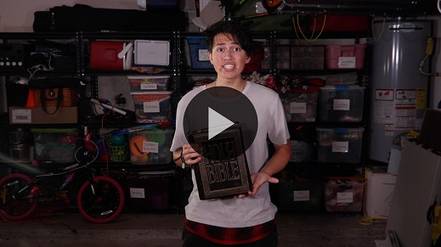

**Bible Story**

**God Delivers from the Fire**

That video was such a fun lead-in to our Bible story! In today’s Bible story, we’ll learn about one of the many times God came through for His followers and delivered them from the hands of their enemies.

Grab your Bible or pull a Bible app up on your device. Turn to [Daniel 3:1–30](https://ref.ly/logosref/Bible.Da3.1-30).

• *Read the Bible story aloud to the group*.

• *In order to keep Large Group time moving along, we don’t recommend having the kids read*.

• *Optional: Remind the kids to mark this place with their Bible Bookmark, so they can read it on their own at home*.

**Teaching Time**

|  |
| --- |
| ***You Will Need***   * *Cell phone* * *Video game or game app* * *Money*   *No prep needed for this activity.* |

That was an incredible Bible story! Even if you’ve heard it before, don’t allow that to stop you from realizing how incredible it really was. God protected three of His faithful followers—Shadrach, Meshach, Abednego—and that reminds us He is the one true God. He not only kept them alive, but also kept them from being burnt while standing inside a furnace. Not even their clothes were burnt.

God delivered them from the fire because they chose to put their trust in Him. They knew He was the one true God. They took that knowledge and put it into action by standing up for what they believed when no one else did. Here’s why that’s important for us.

**1. We follow one God in three Persons**.

• *Show the* ***Teaching Point 1 Slide***.

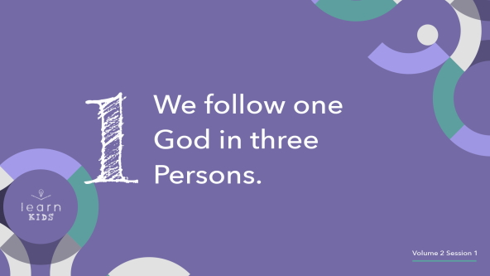

• *As you say “one God in three Persons” throughout this section, hold up fingers to signify the numbers each time. Encourage the kids to follow along with you*.

This can be a confusing thing to wrap our mind around. Did you know there is no one like God on this earth? There never has been. I could tell you that God is like this or like that, but there is nothing like God. He can’t be compared to anything, and that makes Him difficult to fully understand.

It’s important to know that there is only one God. However, He is one God in three Persons. He is the Father, Jesus, and the Holy Spirit. One God in three Persons. Can you say that with me and show the numbers as we say them? *(Group response)*

• *Have kids say it with you and do the numerical actions*.

We call this the *Trinity*. Everyone say, “Trinity.” *(Group response) Trinity* is a word used to explain how God is one God in three Persons. The Father, Jesus, and the Holy Spirit are all powerful, eternal, and unchanging, but each has His own unique job. One is not more awesome or important than another. Remember, there is only one true God in three Persons. Say it with me one last time: One God in three Persons. *(Group response)*

• *Have kids say it with you and do the numerical actions*.

**2. We reject the world’s false alternatives**.

• *Show the* ***Teaching Point 2 Slide***.



In the Bible, people had other gods and idols that were competing for their attention and worship. In today’s Bible story, King Nebuchadnezzar even created his own idol. He made a gold statue and required everyone to bow down and worship it. We may not have a giant gold statue to bow down to, but there are many “idols” or false alternatives that the world has created. They distract us from worshipping and spending time with the one true God.

What’s something you can think of that can distract us from God? *(Allow responses.)* Those are good answers. Idols aren’t just something in Bible times. Anything can be turned into an idol if we worship it instead of God.

• *Hold up a cell phone*.

Phones and devices can become idols if we spend so much time on them that they are more important to us than God. We can spend hours a day watching videos, scrolling on social media, and wishing we could be just like our favorite influencers.

• *Hold up a video game or show a game app*.

Video games can become idols if we put them before God.

• *Hold up money*.

Money can become an idol when we allow it to control our thoughts and actions. This can happen if we make the things we want to buy more important than God. It also can happen if money is so important to us that we refuse to share with others in need like God’s Word teaches. We must be careful not to allow money to become an idol in our life that replaces God. We have to make the one true God number one in our life.

**3. We put our trust in the one true God**.

• *Show the* ***Teaching Point 3 Slide***.

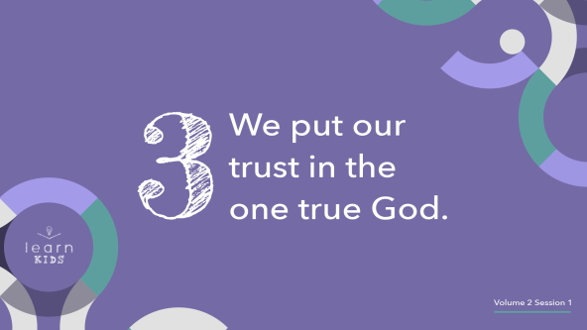

We can look to Shadrach, Meshach, and Abednego as examples for us to follow. They knew that they served the one true God. The gold statue King Nebuchadnezzar had created was no match for God. The three men completely rejected the statue and the concept of worshipping anyone or anything other than God. They literally took a risky stand when they chose to remain standing when everyone else was bowing down to the statue.

They trusted that God would be able to save them. The best part is that they wouldn’t change their decision to follow Him even if He didn’t save them. They told the king they would never worship his statue. Those are strong and sacrificial words. We may never have to face an evil king or be forced to choose between our life and following God, but there will be times when we need to choose to trust God.

• *Finish by sharing a simple story of a time when you had to trust God*.

• *Consider asking kids to share if they have a story when they had to trust God*.

**Prayer and Response**

*Consider playing a worship song softly in the background while kids pray*.

Are you willing to take a stand and put your trust in the one true God like Shadrach, Meshach, and Abednego did? If you believe that God is the one true God and you want to put your trust fully in Him, let’s take a stand together right now. Stand up where you are, raise your hands, and offer your life fully to God. Be bold and stand up for what you believe in.

**Prayer**

• *Optional: Have the kids repeat phrases of the prayer after you*.

|  |
| --- |
| Dear God, we raise our hands as a sign of surrender to You. We know You are the one true God, and we place our life in Your hands. Help us to stand up for what’s right even if no one else does. Help us to trust You even if it’s hard. Help us to know that like Shadrach, Meshach, Abednego, You are with us all the time. We love You. Amen. |

**Faith Verse**

I’m glad we’re learning more about God together. He’s so amazing, and we can spend our entire life getting to know Him more. Our Faith Verse reminds us just how incredible God is. Let’s learn it together.

• *Play* ***Faith Verse Video***.

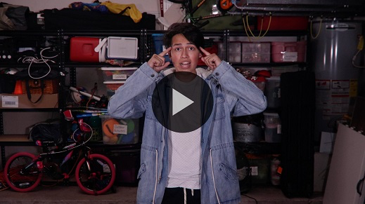

[Isaiah 55:8](https://ref.ly/logosref/Bible.Is55.8) (NLT)

“My thoughts are nothing like your thoughts,” says the Lord. “And my ways are far beyond anything you could imagine.”

This is a great reminder that our God is so much wiser that we are. His plans are so much bigger than we could imagine. When things don’t go the way we planned, we can know that it is never a surprise to God. Our God is the one true God. We can put our trust in Him and His plans instead of our own.

**Faith Fact**

Before we go to our small groups, let’s review our Faith Fact one more time.

• *Show the* ***Faith Fact Slide***.



Say it with me. **My God is the one true God**. I hope you will always remember that. Thanks for joining me today. Let’s go to our small groups.

• *Dismiss kids to Small Group time or to go home if your group time ends here*.

**Small Group**

**30 Minutes**

*This section can be done in conjunction with the large group or on its own if you do small groups with your kids. During Small Group time, the goal is to connect the kids with the Word of God and to each other. All activities are led by the small group leader.*

**Group Connection**

**One Thing**

We’re going to get to know each other better one thing at a time. For each round of this game, I’ll give you different instructions. Then, everyone will share one thing about themselves. You can only share one thing in each round, no more or no less. Are you ready? *(Group response)*

• Share one hobby or interest you have.

• Share one thing you love about your family.

• Share one thing you like to eat.

• Share one word to describe yourself.

• Share one thing most people don’t know about you.

• Share one word that describes how you feel right now.

Thanks for sharing! I know a lot more about you. Now, I’d like us to share more about God. Let’s talk about Him and His Word.

• Share one thing you love about God.

• Share one thing that surprises you about God.

• Share one Bible verse you love.

Awesome! Now, I know a lot more about God, too. Thanks for sharing.

**Learn about It**

|  |
| --- |
| ***You Will Need***   * *Bibles for kids in your group to share*   *No prep needed for this activity.* |

**Scripture Search:** [**Isaiah 45:18**](https://ref.ly/logosref/Bible.Is45.18)**;** [**Exodus 20:3**](https://ref.ly/logosref/Bible.Ex20.3)**;** [**Hosea 13:4**](https://ref.ly/logosref/Bible.Ho13.4)**;** [**Joel 2:27**](https://ref.ly/logosref/Bible.Joe2.27)

Let’s dig deeper into God’s Word and see what else we need to know about Him. As we find and read each of these verses, let’s consider: What does this Scripture mean for our life today?

• *Give each kid a Bible and search for one or more of the Scriptures as a group together (as time allows). When everyone has found the Scripture, have one of the kids read it. Then answer the questions about it*.

• *Pair kids who need additional help with older kids or start simple and look up the session’s Bible story Scripture:* [*Daniel 3:1–30*](https://ref.ly/logosref/Bible.Da3.1-30)*. Kids will get better finding Scriptures the more they practice*.

• *Optional: Make this a competition to see who can find the Scripture first*.

**Bible Reading Tip**

One way to get to know God better is to commit to reading your Bible and spending time with God every single day. Choose to do that before doing anything else. When we choose to put God first in our day, it will be easier to put Him first in our life.

**Challenge**

Choose one verse to memorize this week. You can choose our Faith Verse, [Isaiah 55:8](https://ref.ly/logosref/Bible.Is55.8), or one of the verses we just read. Write it on a notecard or ask your parent to help you write it on your bathroom mirror with a washable marker so you see it every morning while you’re getting ready.

**Faith Fact**

Reading these verses is a reminder to me of our Faith Fact: **My God is the one true God**. Say it with me. **My God is the one true God**.

**Group Discussion**

*Feel free to use all or just a few questions as a jumping-off place for good discussion. Questions marked with * are designed for more conversation. Adjust the questions based on the age or maturity of your group. Typically, older kids will be able to dive a little deeper than younger ones*.

**Questions**

• *If small group activities are not immediately following large group time, you may want to read the Bible story passage before this discussion*.

What did King Nebuchadnezzar create?

What did he command everyone to do?

Who refused to bow down to the king’s statue?

What happened after Shadrach, Meshach, and Abednego were thrown into the furnace?

What did the king do after he saw God rescue Shadrach, Meshach, and Abednego?

* What would you have been thinking about if you’d been there?

* What do you think you would have done if you’d been there?

* What is one thing that helps you trust in the one true God?

* What is one idol you struggle with? How can you reject it?

**Prayer Requests**

*Finish group discussion by sharing prayer requests and praise reports. Keep track of your small group’s prayer requests and review them each time you meet*.

**Prayer**

*Have kids pray for each other’s prayer requests*.

**Faith Verse Review**

|  |
| --- |
| ***You Will Need***   * ***Small Group Faith Verse Review****, one set per kid, pair, or team* * *Scissors*   ***Getting Ready***   * *Print and cut out the pieces of the* ***Small Group Faith Verse Review****, one set per kid, pair, or team.* |

Our Faith Verse is [Isaiah 55:8](https://ref.ly/logosref/Bible.Is55.8). It tells us that God’s thoughts and ways are very different and much better than our own. Let’s say the Faith Verse together.

• *Show* ***Faith Verse Video***.



[Isaiah 55:8](https://ref.ly/logosref/Bible.Is55.8) (NLT)

“My thoughts are nothing like your thoughts,” says the Lord. “And my ways are far beyond anything you could imagine.”

Let’s say the Faith Verse a couple times as a group before we play a game.

• *Say the verse as a group a couple of more times*.

**Faith Verse Fun**

**Verse Scramble**

Now, let’s play a game. Let’s see how quickly you can put the words of the entire Faith Verse in order.

• *Scramble the* ***Small Group Faith Verse Review*** *slips so they are no longer in the correct order of the verse*.

• *Have individual kids, pairs of kids, or teams compete to see who can put the verse in the correct order the fastest*.

• *Read the verse to practice it each time the verse is put together*.

You’ve done a great job of saying this verse together. Let’s think about what this verse means. How would you explain this verse to someone who doesn’t know God? *(Allow responses.)*

**Activity Page**

**One Word**

|  |
| --- |
| ***You Will Need***  *•* ***Small Group Activity Page****, one per kid*  *• Pencils or pens, one per kid*  ***Getting Ready***  *• Print copies of the* ***Small Group Activity Page****, one per kid.* |

Today’s Faith Fact is **My God is the one true God**. Aren’t you glad that we can know and worship the one true God instead of some gold statue? *(Group response)* We can know and trust that our God hears us when we pray. He can deliver us from difficult situations like He did for Shadrach, Meshach, and Abednego. Not everyone in today’s Bible story knew how to trust God.

• *Give each kid a copy of the* ***Small Group Activity Page*** *and a pencil*.

Here’s what you need to do. Look at these pictures of people and things from our Bible story. Think of one word that describes each. For example, how would you describe Shadrach, Meshach, and Abednego? *(Allow responses.)* Below each picture, write the word that you choose. Then, we’ll compare answers.

• *Give kids time to complete this activity. If it’s too challenging for kids to do on their own, talk about each picture together*.

• *Have them share their descriptions with the group if you have time*.

**Dismissal**

I’m so glad you were here to learn about God with me today. Let’s close in prayer.

**Prayer**

|  |
| --- |
| *Dear Father God, thank You for always being there for us and allowing us to get to know You better. Help us to worship only You and to put You first in our life. Amen.* |

**Faith Fact Recap**

• *Show the* ***Faith Fact Slide***.



One important thing I want you to remember from today is our Faith Fact. Let’s say it together one more time. **My God is the one true God**. I’m glad you came today. I can’t wait to see you next time.

• *Send home the* ***Small Group Activity Page***.

• *Remind parents that there are* ***Family Devotions*** *available on the app to do with their kid*.

• *Tell everyone the date and time for the next session*.